Section 8.1: Multiplying Monomials

SOLs: None

Objectives: Students will be able to:
Multiply monomials
Simplify expressions involving powers of monomials

Vocabulary:
Monomial – a number, a variable, or a product of a number and one or more variables
A single term: 6, 2x, 14xy, -3x²y⁴
(includes products, but not quotients)
Constant – a monomial that is a real number

Key Concept:

Examples:

- Determine whether each expression is a monomial. Explain your reasoning.
 | Expression | Monomial? | Reason
a. | 17 – s
b. | 8f²g
c. | ¾
d. | xy
- Simplify the following:
a. $(r^{4})(−\text{12}r^{7})$ b. $(6{\text{cd}}^{5})(5c^{5}d^{2})$

- Simplify $(((2^{3})^{3})^{2}$

- Geometry: Find the volume of a cube with a side length, s = 5xyz

- Simplify [(8g³h⁴)²]²(2gh⁵)⁴

Concept Summary:
A monomial is a number, a variable, or a product of a number and or one or more variables
To multiply two powers that have the same bass, add exponents
To find a power of a power, multiply exponents
The power of a product is the product of powers

Homework: pg 413 16-40 even
Section 8.2: Dividing Monomials

SOLs: The student will

Objectives: Students will be able to:
Simplify exponents involving the quotient of monomials
Simplify expressions containing negative exponents

Vocabulary:
Zero exponent – for any nonzero number a, a⁰ = 1
Negative exponent – for any nonzero number a and any integer n, a^{-n} = 1/a^{n} and 1/a^{-n} = a^{n}

Key Concept:
Examples:
- Simplify $\frac{x^{7}y^{\text{12}}}{x^{6}y^{3}}$. Assume that x and y ≠ 0.

- Simplify ${\left(\frac{4c^{3}d^{2}}{5m^{4}n^{7}}\right)}^{3}$. Assume that e and f ≠ 0.

- a. Simplify ${\left(\frac{\text{12}m^{8}n^{7}}{8m^{5}n^{\text{10}}}\right)}^{0}$. Assume that m and n ≠ 0.
b. Simplify $\frac{m^{0}n^{3}}{n^{2}}$. Assume that m and n ≠ 0.

- a. Simplify $\frac{x^{−6}}{y^{−6}z^{9}}$. Assume that y and z ≠ 0.
b. Simplify $\frac{\text{75}p^{3}q^{−5}}{\text{15}p^{5}q^{−4}r^{−8}}$. Assume that p, q, and r ≠ 0.

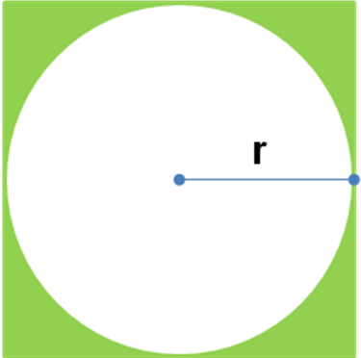
- Multiple-Choice Test Item: Write the ratio of the circumference of the circle to the area of the square in simplest form.
A. $\frac{2r}{π}$ B. $\frac{2π}{r}$
C. $\frac{π}{2r}$ D. $\frac{2πr}{1}$

Concept Summary:
To divide two powers with the same base, subtract the exponents
To find the power of a quotient, find the power of the numerator and the power of the denominator
Any nonzero number raised to the zero power is 1
For any nonzero number a and any integer n,
a^{-n} = 1/a^{n} and 1/a^{-n} = a^{n}

Homework: pg 421 14-36 even
Section 8.3: Scientific Notation

SOLs: None

Objectives: Students will be able to:
Express numbers in scientific notation and in standard form
Find products and quotients of numbers expressed in scientific notation

Vocabulary:
Scientific notation – a number of the form a × 10^{n}, where 1 ≤ a < 10 and n is the integer

Key Concept:

Examples:

- a. Express 7.48×10⁻³ in standard notation
b. Express 2.19 ×10⁵ in standard notation

- a. Express 0.000000672 in scientific notation
b. Express 3,022,000,000,000 in scientific notation
- The Sporting Goods Manufacturers Association reported that in 2000, women spent $4.4 billion on 124 million pairs of shoes. Men spent $8.3 billion on 169 million pairs of shoes. Express the numbers of pairs of shoes sold to women, pairs sold to men, and total spent by both men and women in standard notation and scientific notation.

- Evaluate $\left(7×{\text{10}}^{−6}\right)\left(4\text{.}3×{\text{10}}^{\text{12}}\right)$. Express the result in scientific and standard notation.

- Evaluate $\frac{6\text{.}4×{\text{10}}^{4}}{1\text{.}6×{\text{10}}^{7}}$. Express the result in scientific and standard notation.

Concept Summary:
A number is expressed in scientific notation when it is written as a product of a factor and a power of 10. The factor must be greater or equal to 1 and less than 10

Homework: pg 428 18-54 even
Section 8.4: Polynomials

SOLs: The student will

Objectives: Students will be able to:
Find the degree of a polynomial
Arrange the terms of a polynomial in ascending or descending order

Vocabulary:
Polynomial – a monomial or the sum of monomials
Binomial – the sum of two monomials
Trinomial – the sum of three monomials
Degree of a monomial – the sum of the exponents of all its variables
Degree of a polynomial – the greatest degree of any term in the polynomial

Key Concept:

Examples:

- State whether each expression is a polynomial.
If it is a polynomial, identify it as a monomial, binomial, or trinomial.

 | Expression | Polynomial (why or why not)? | Monomial, Binomial, or Trinomial
a. | 6 – 4
b. | x² + 2xy – 7
c. | $$\frac{\text{14}d+\text{19}e^{2}}{5d^{4}}$$
d. | 26b⁵
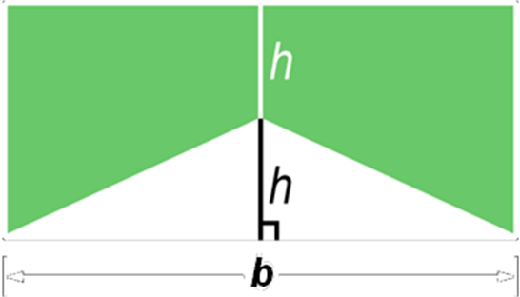

- Write a polynomial to represent the area of the green shaded region.

- Find the degree of each polynomial.

 | Polynomial | Terms | Degree of each term | Degree of Polynomial
a. | 12 + 5b + 6bc + 8bc²
b. | 9x² – 2x – 4
c. | 14g²h⁵i

- Arrange the terms so that the powers of x are in ascending order.
a. 16 + 14x³ + 2x – x²
b. 7y² + 4x³ + 2xy³ – x²y²
- Arrange the terms so that the powers of x are in descending order.
a. 8 + 7x² – 12xy³ – 4x³y
b. a⁴ + ax² – 2a³xy³ – 9x⁴y

Concept Summary:
A polynomial is a monomial or a sum of monomials
A binomial is the sum of two monomials, and trinomial is the sum of three monomials
The degree of a monomial is the sum of the exponents of all its variables
The degree of a polynomial is the greatest degree of any term. To find the degree of a polynomial, you must find the degree of each term

Homework: pg 434 16-52 even
Section 8.5: Adding and Subtracting Polynomials

SOLs: The student will

Objectives: Students will be able to:
Add polynomials
Subtract polynomials

Vocabulary: None new

Key Concept: Combine “like” or similar terms (monomials) and simplify

Examples:

- Find (7y² + 2y – 3) + (2 – 4y + 5y²)

- Find (6y² + 8y⁴ – 5y) – (9y⁴ – 7y + 2y²)

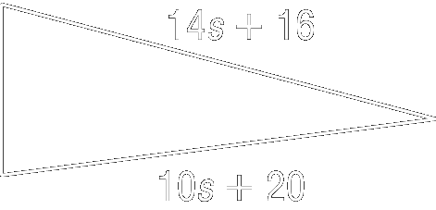
- Geometry:
a. The measure of the perimeter of the triangle shown is 37s + 42.
Find the polynomial that represents the third side of the triangle.
|
b. Find the length of the third side if the triangle if s = 3

Concept Summary:
To add polynomials, group like terms horizontally or write them in column form, aligning the like terms vertically
Subtract polynomials by adding its additive inverse. To find the additive inverse of a polynomial, replace each term with its additive inverse

Homework: pg 441 12-30 even
Section 8.6: Multiplying Polynomials by a Monomial

SOLs: None

Objectives: Students will be able to:
Find the product of a monomial and a polynomial
Solve equation involving polynomials

Vocabulary: none new

Key Concept:
Examples:

- Find 6y(4y² – 9y – 7)

- Simplify 3(2t² – 4t – 15) + 6t(5t + 2)

- Entertainment: Admission to the Super Fun Amusement Park is $10. Once in the park, super rides are an additional $3 each and regular rides are an additional $2. Sarita goes to the park and rides 15 rides, of which s of those 15 are super rides. Find an expression for how much money Sarita spent at the park.

- Solve b(12 + b) – 7 = 2b + b(-4 + b)

Concept Summary:
The Distributive Property can be used to multiply a polynomial by a monomial

Homework: pg 446 16-48 even
Section 8.7: Multiplying Polynomials

SOLs: None

Objectives: Students will be able to:
Multiply two binomials by using the FOIL method
Multiply two polynomials by using the Distributive Property

Vocabulary:
FOIL method – to multiply two binomials, find the sum of the products of
the First terms,
the Outer terms,
the Inner terms, and
the Last terms.

Key Concept:

Examples:

- Find (y + 8)(y – 4)

- a. Find (z – 6)(z – 12)
b. Find (5x – 4)(2x + 8)
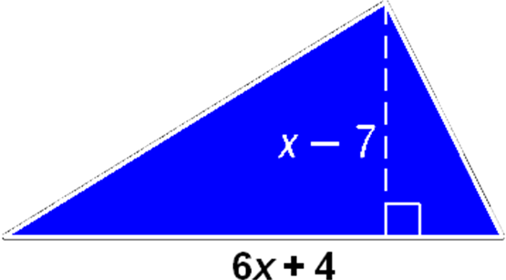
- Geometry: The area A of a triangle is one-half the height h times the base b. Write an expression for the area of the triangle.

- a. Find (3a + 4)(a² – 12a + 1)
b. Find (2b² + 7b + 9)(b² + 3b – 1)

Concept Summary:
The FOIL method is the sum of the products of the first terms F, the outer terms O, the inner terms I, and the last terms L
The Distributive Property can be used to multiply any two polynomials

Homework: pg 455 20-38 even
Section 8.8: Multiplying Polynomials by a Monomial

SOLs: None

Objectives: Students will be able to:
Find the squares of sums and differences
Find the product of a sum and a difference

Vocabulary:
Difference of squares – two perfect squares separated by a subtraction sign:
a² – b² = (a + b)(a - b) or (a – b)(a + b).

Key Concept:

Examples:

- a. Find (7z + 2)²
b. Find (5q + 9r)²

- a. Find (3c – 4)²
b. Find (6e – 6f)²

- Geometry: Write an expression that represents the area of a square that has a side length (2x + 12) units

- a. Find (9d – 4)(9d + 4)
b. Find (10g + 13h³)(10g – 13h³)

Concept Summary:
The Distributive Property can be used to multiply a polynomial by a monomial

Homework: pg 446 16-48 even
Section 8.R: Review of Chapter 8

SOLs: None

Objectives: Students will be able to:
Review material learned in the chapter

Vocabulary: none new

Key Concept:

Examples:

- x

- x

- x

Concept Summary:
xxxx

Homework: none

